
ST ANDREW’S JUNIOR COLLEGE
Preliminary Examinations
Higher 2

H2 Geography 9173/02
Paper 2 16 September 2025
INSERT 3 hours

READ THESE INSTRUCTIONS FIRST

This insert contains all the Resources referred to in the questions.

This document consists of 9 printed pages.

[Turn over
Resource 1 for Question 1

Map of East Coast Park

East of East Coast Park

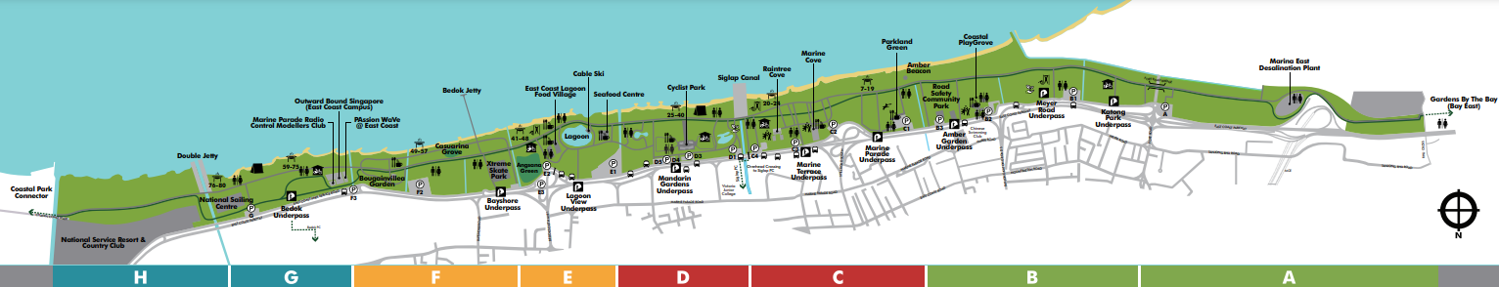

West of East Coast Park

The entire length of East Coast Park is 15 km.

= Sample site
A, B, C D, E, F, G, H = Zones within East Coast Park

Resource 2 for Question 1

The proposed development of Long Island along East Coast Park

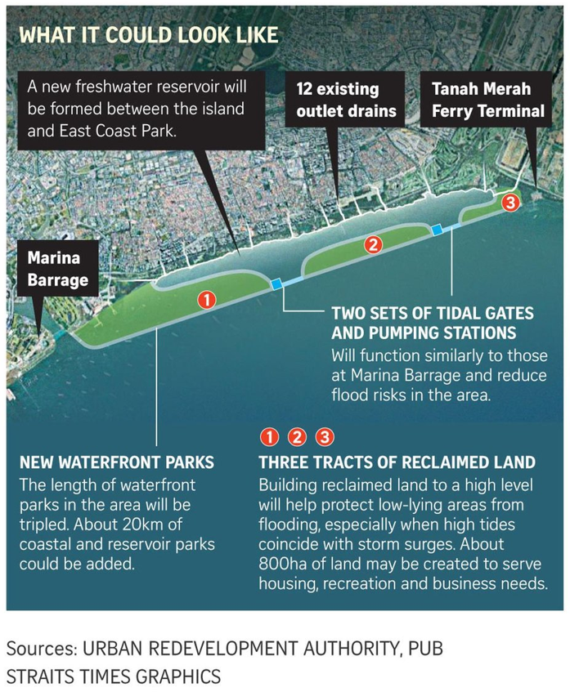

[Turn over
Resource 3 for Question 1

Photograph of the survey being conducted at the East Coast Lagoon Food Village


Resource 4 for Question 1
Survey questions

1. Have you heard about the proposed 'Long Island' reclamation project?
☐ Yes, I know what it is ☐ Heard of it, but not sure ☐ No, this is new to me

2. Which of the following do you think Long Island will bring? (Tick all that apply)
☐ Coastal protection ☐ Freshwater supply ☐ Recreation/amenities ☐ Loss of park space
☐ Unsure

3. Do you support the construction of Long Island?
☐ Strongly support ☐ Somewhat support ☐ Neutral ☐ Somewhat oppose ☐ Strongly oppose

4. Would you use the potential reservoir (e.g. canoeing, dragon-boating)?
☐ Yes ☐ Maybe ☐ No

5. Which group best describes you?
☐ Cyclist ☐ Jogger/runner ☐ Family with children ☐ Food-centre visitor ☐ Other: ______

[Turn over
Resource 5A for Question 1

Support levels by user type (n=20)

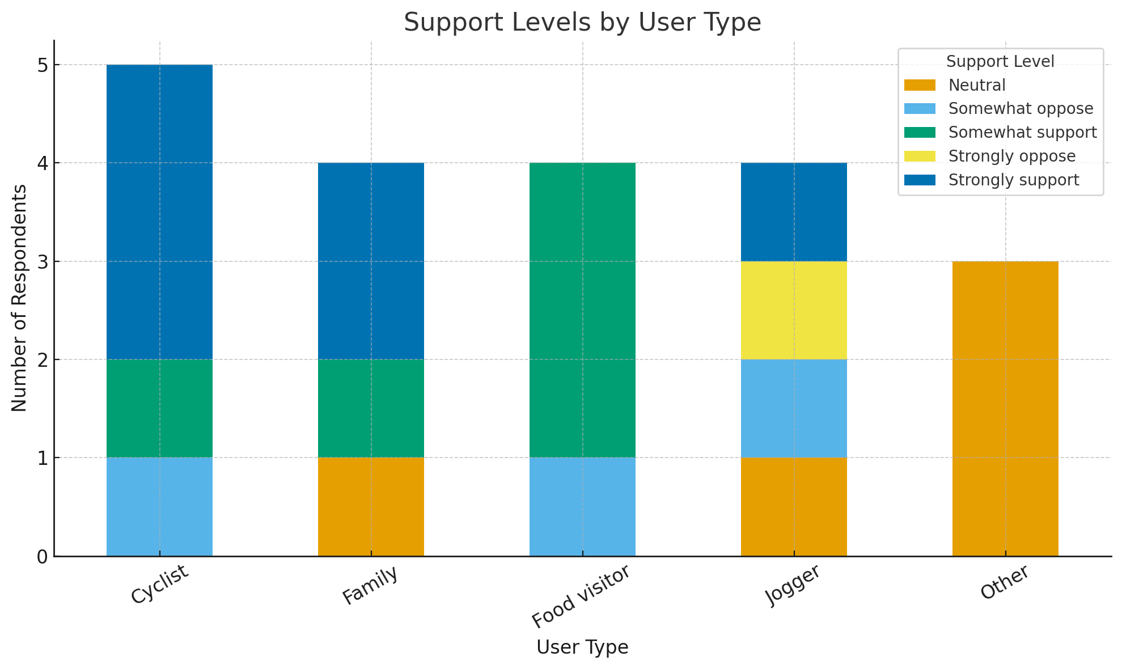

Resource 5B for Question 1

Degree of support (n=20)

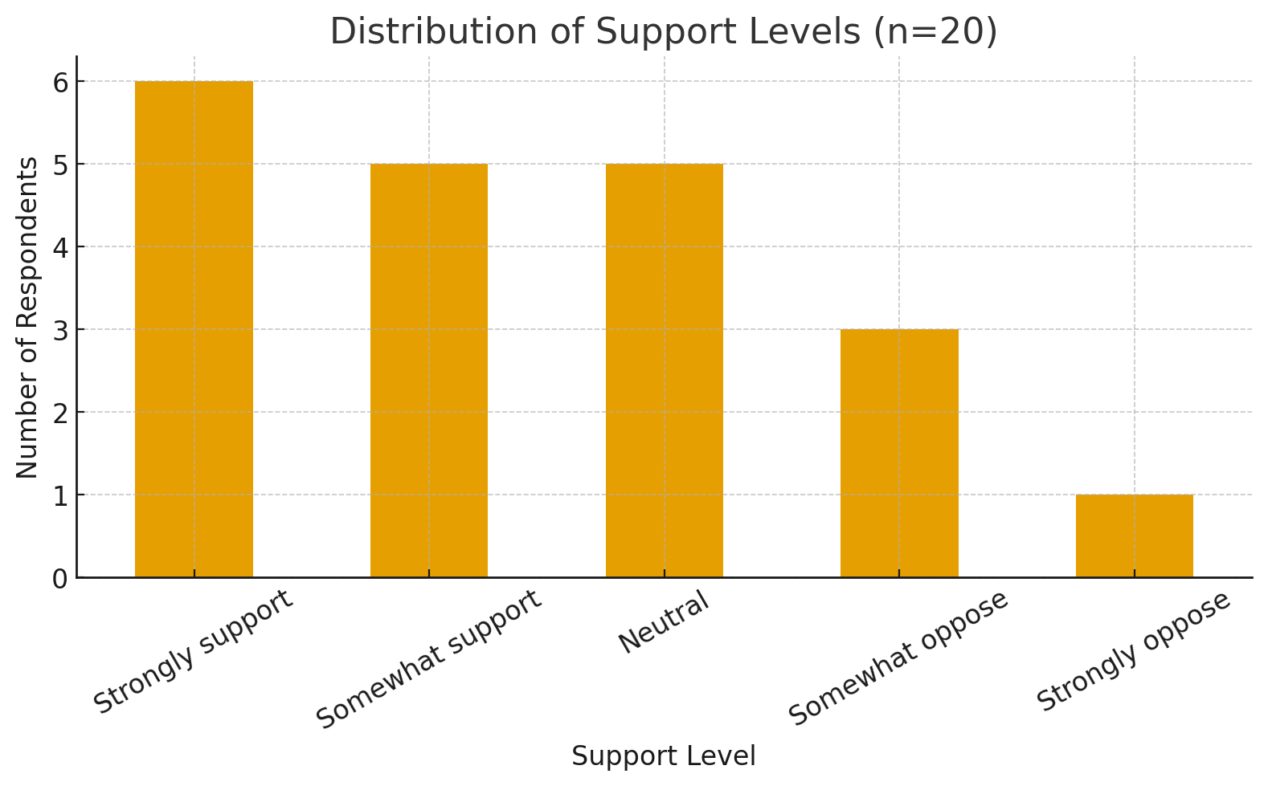

[Turn over

Resource 6 for Question 1

Extracts of secondary data from newspaper reports and government publications

Government Press Release (2023):
- Long Island will safeguard Singapore against sea-level rise and storm surges.
- The lagoon may serve as an additional reservoir to boost water security.
- Reclamation will enhance recreation (e.g. water sports, waterfront promenades).

Newspaper Article (2024):
- Environmental groups express concern over loss of marine ecosystems and reduced green space at East Coast Park.
- Some residents worry about construction disruption and the visual impact on the coastline.

Resource 7 for Question 2

The impact of climate change on the urban environment

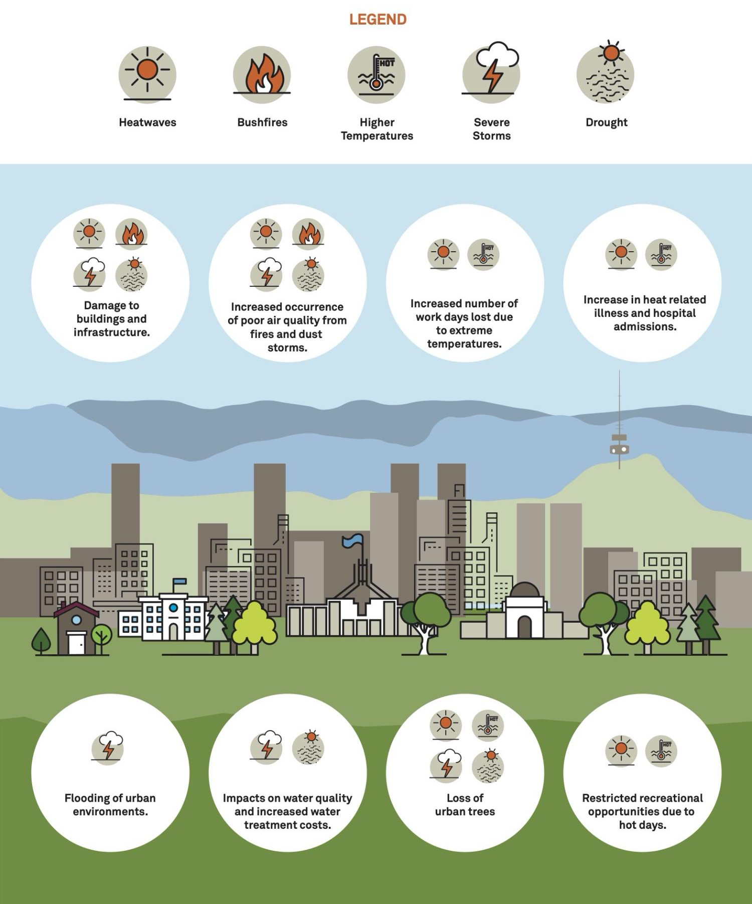
Equator
[Turn over
Resource 8 for Question 2

Strategies to respond to climate change in New Washington, Aklan (Philippines) and Hartlepool Dock (United Kingdom)
Seawall structures in New Washington, Aklan (Philippines)
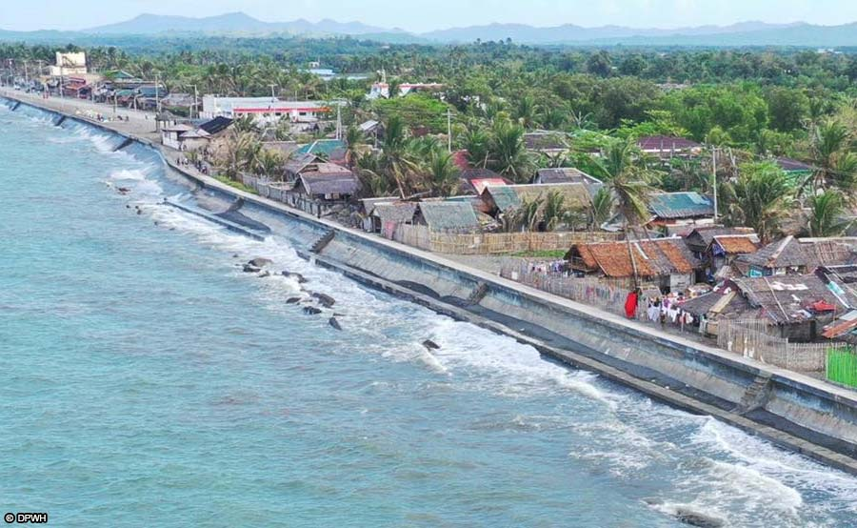
Seawall structures in Hartlepool Dock (United Kingdom)
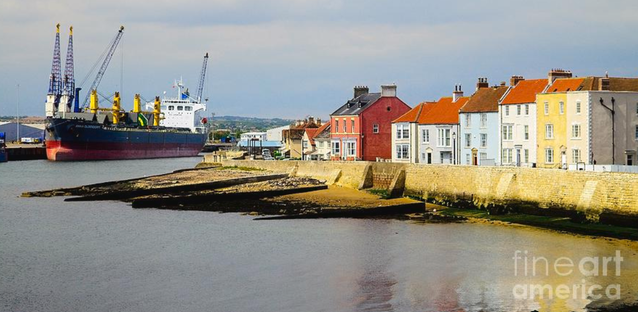

Resource 9 for Question 2

The role of states, non-governmental organisations (NGOs) and firms in India’s response to climate change across six partnership dimensions

